BALLFIELD RENTAL APPLICATON
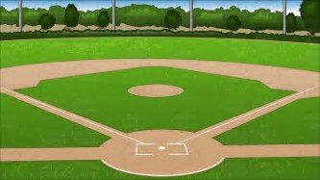

Ballfield: Southview Community Center 1 Hickory Community Center II
Date of Rental: __________________________________________
Number of Days per Week: ________________________________
Days of the Week: ________________________________________
Team Name: ___________________________________________
Name: __________________________________________________
Address: ________________________________________________
________________________________________________
Phone Number: __________________________________________
Resident: Yes No
Ballfield Rental Fee paid: $ ________ Cash Check# _______
Residents & Township Based Leagues: No Fee
Non-Residents: $50 Per Rental (3 hours)

Date Ballfield was reserved: ______________________________
Date Paid: _____________________________________________

RESERVATIONS FOR BALLFIELD FACILITIES SUBMITTED BY TOWNSHIP-BASED LEAGUES (FT. CHERRY SOFTBALL ORGANIZATIONS) THROUGH MARCH 31ST SHALL BE GIVEN PREFERENCE IN SCHEDULING. RESERVATIONS RECEIVED BY TOWNSHIP RESIDENTS THROUGH MARCH 31ST SHALL BE GIVEN PREFERENCE TO REMAINING FIELDS/TIMES NOT RESERVED BY TOWNSHIP-BASED LEAGUES, BEFORE RESERVATIONS FOR NON-RESIDENT LEAGUES OR INDIVIDUALS ARE APPROVED. ALL RESERVATIONS MADE ON OR AFTER APRIL 1ST SHALL BE PROCESSED IN ORDER OF APPLICATION. LEAGUES MUST FURNISH COMPLETE SCHEDULE FOR PRACTICES AND GAMES WHEN COMPLETING THIS RENTAL APPLICATION AND SUBMIT UPDATES TO THE SCHEDULE IMMEDIATELY UPON ANY CHANGES.

